**Outlier Analysis using Scatter Plot for Dense Cluster**

1. **Synthetic Data**

**N : 10000, D : 2 , K : 3**

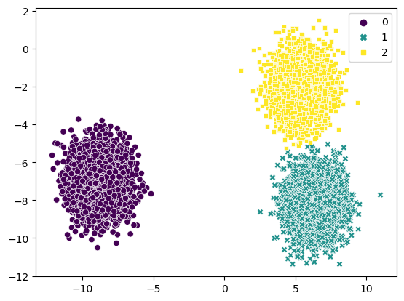

Clusters Obtained by applying Kmeans

* **Isolation Forest**

1. Contamination = ‘auto’

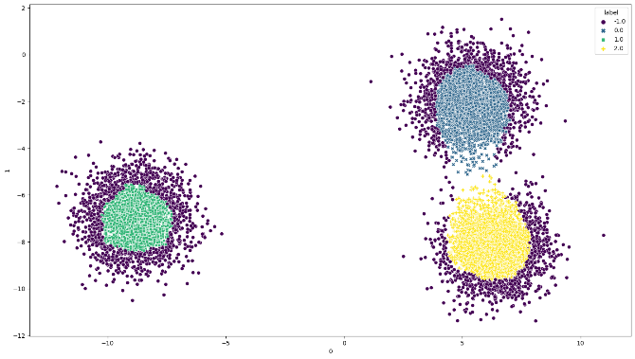 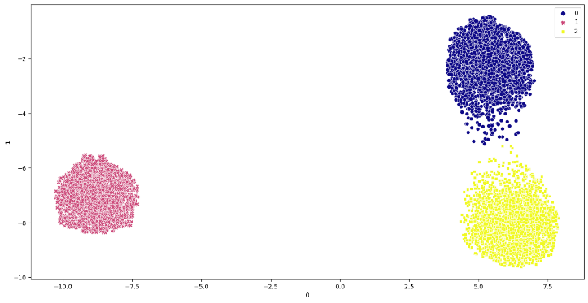

Obtained Outliers Obtained Clusters after removing Outliers

1. Contamination = 0.025

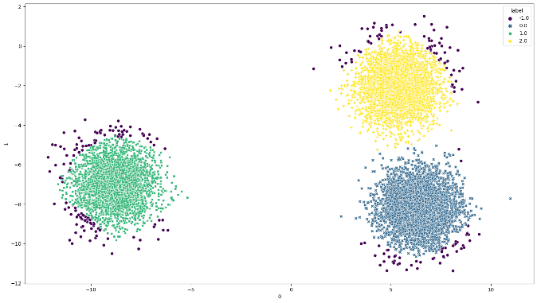 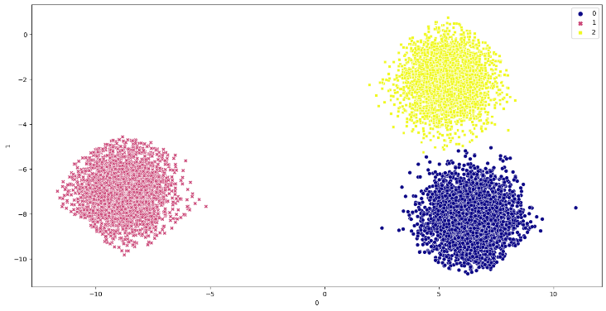

Obtained Outliers Obtained Clusters after removing Outliers

Contamination = 0.05

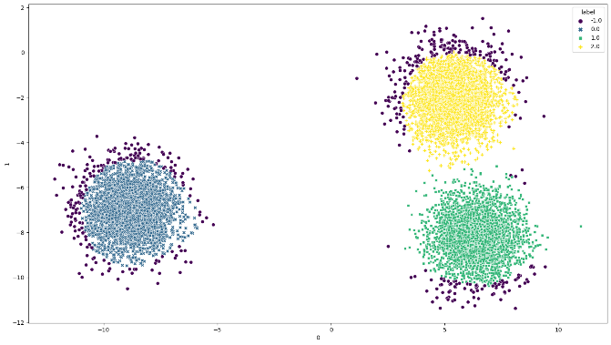 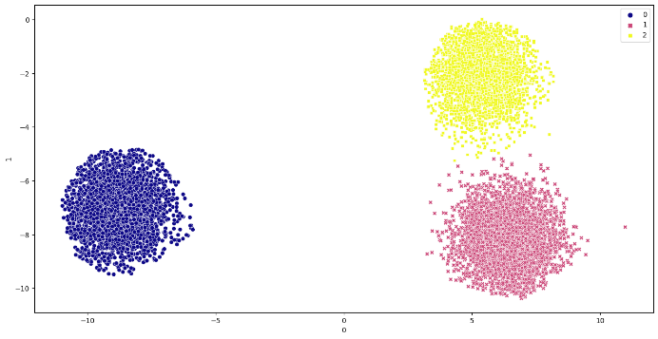

Obtained Outliers Obtained Clusters after removing Outliers

Contamination = 0.1

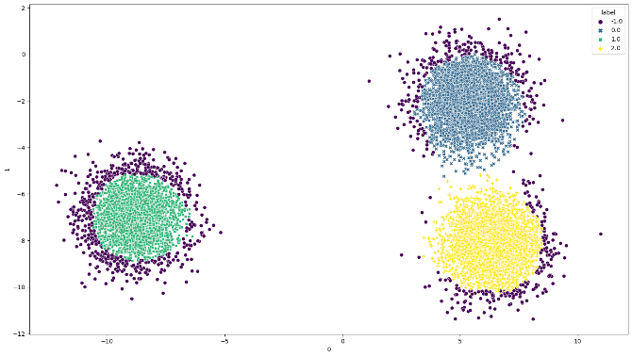 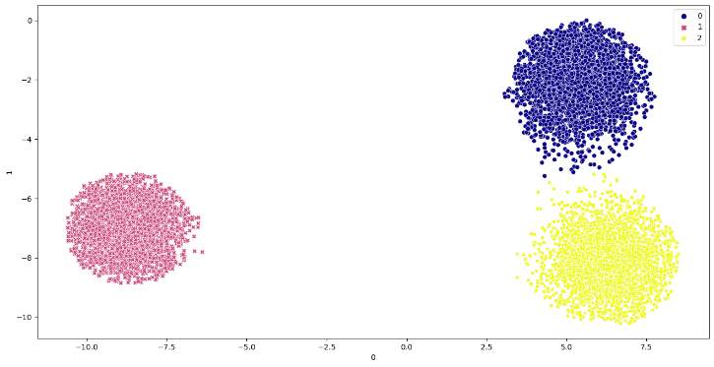

Obtained Outliers Obtained Clusters after removing Outliers

* **Local Outlier Factor**

Contamination = ‘auto’

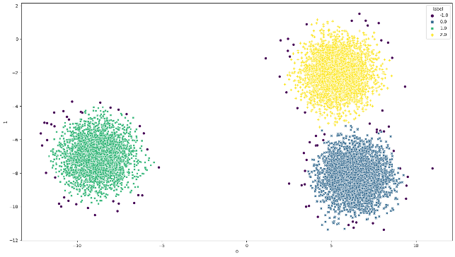 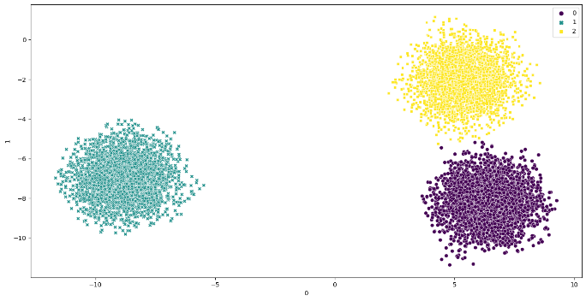

Obtained Outliers Obtained Clusters after removing Outliers

Contamination = 0.025

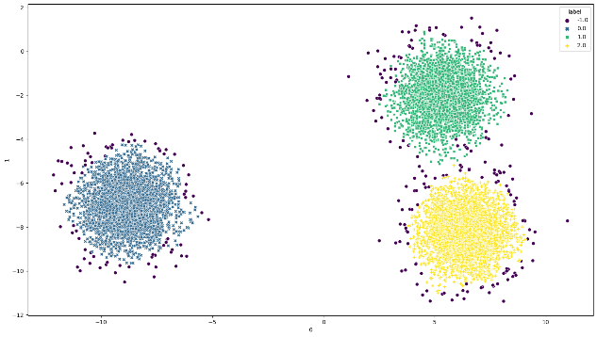 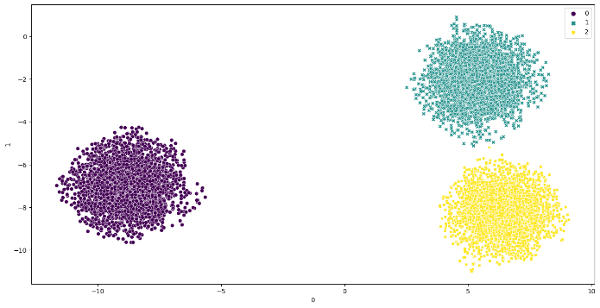

Obtained Outliers Obtained Clusters after removing Outliers

Contamination = 0.05

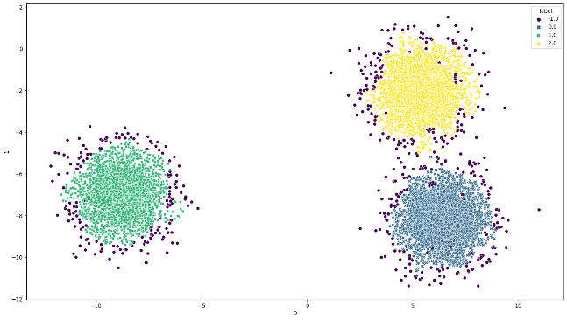 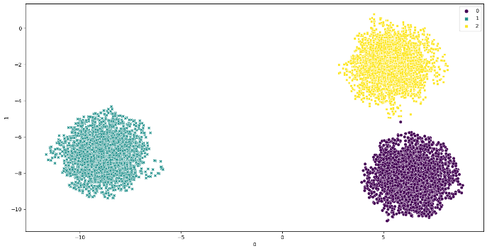

Obtained Outliers Obtained Clusters after removing Outliers

Contamination = 0.1

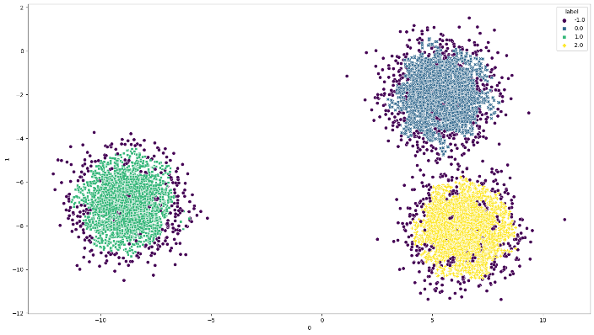 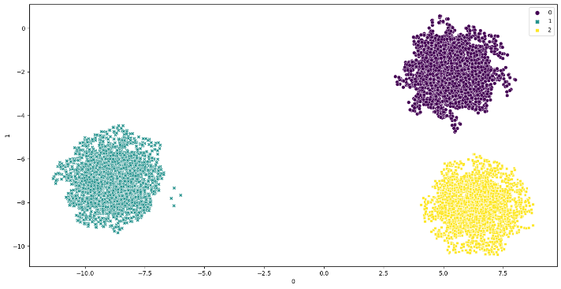

Obtained Outliers Obtained Clusters after removing Outliers

Contamination = 0.05 , n_neighbors = 1000

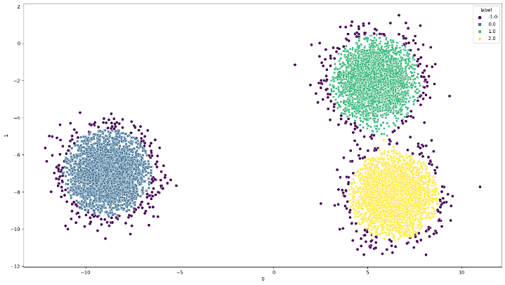 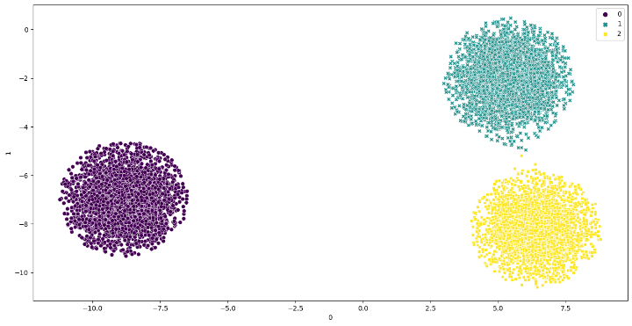

Obtained Outliers Obtained Clusters after removing Outliers

Contamination = 0.1 , n_neighbors = 1000

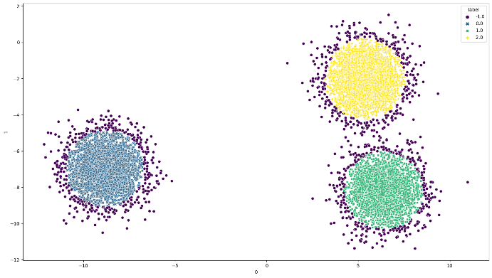 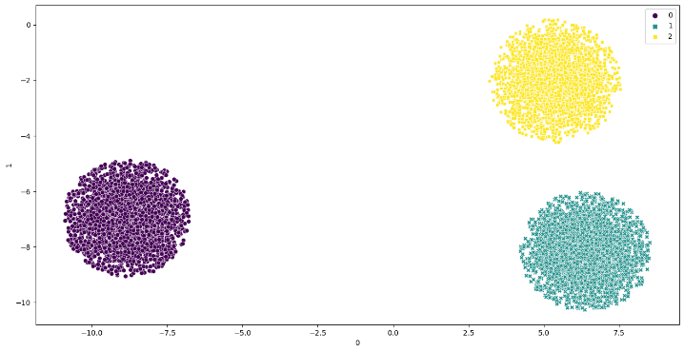

Obtained Outliers Obtained Clusters after removing Outliers

* **One Class SVM**

( Unlike other outlier detection algorithms One Class SVM has nu parameter which is equivalent to contamination )

nu = ‘auto’

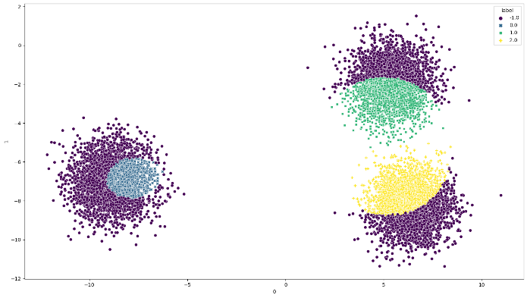 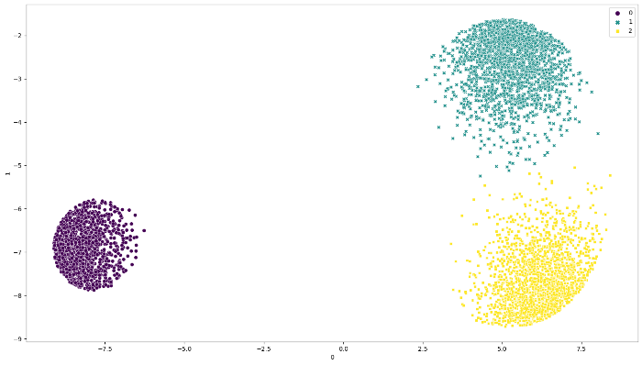

Obtained Outliers Obtained Clusters after removing Outliers

nu = 0.025

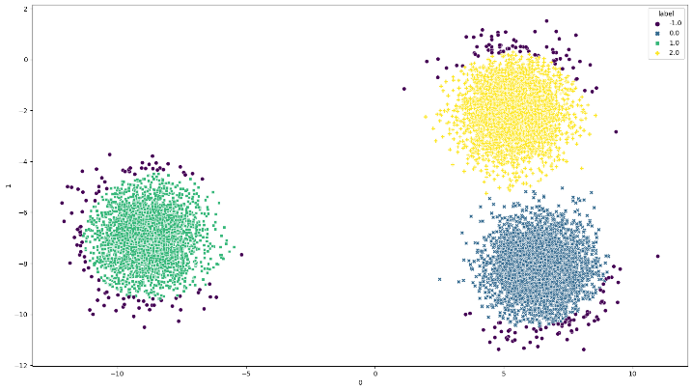 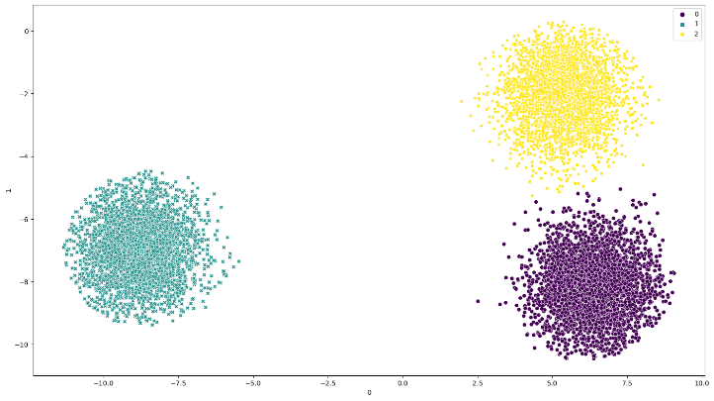

Obtained Outliers Obtained Clusters after removing Outliers

nu = 0.05

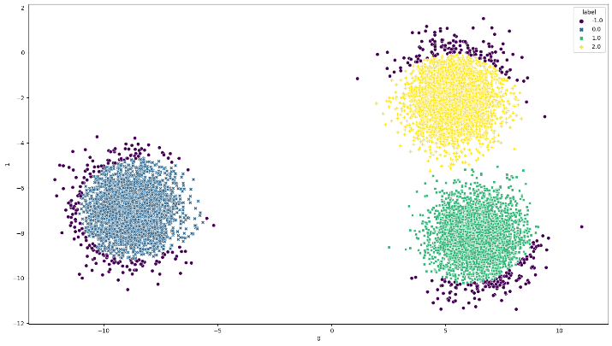 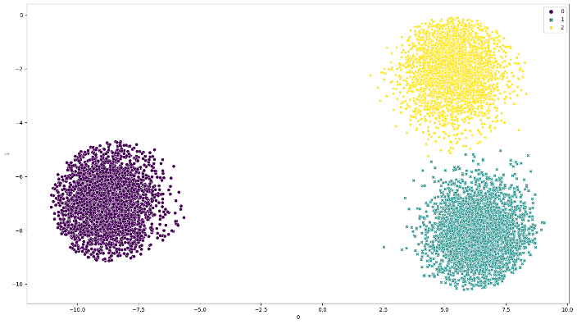

Obtained Outliers Obtained Clusters after removing Outliers

nu = 0.1

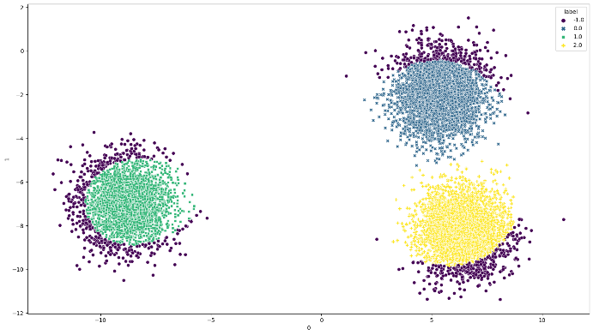 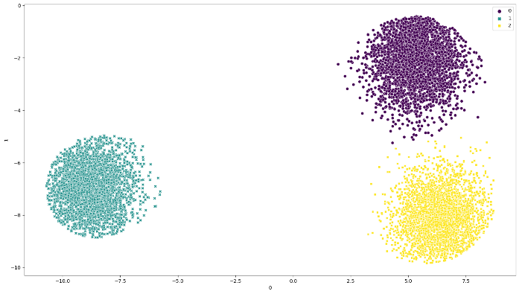

Obtained Outliers Obtained Clusters after removing Outliers

1. **Synthetic Data**

**N : 10000, D : 2, K : 2**

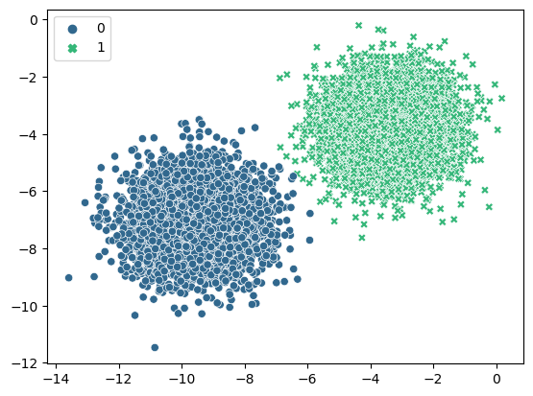

Clusters obtained by applying Kmeans

* **Isolation Forest**

Contamination = ‘auto’

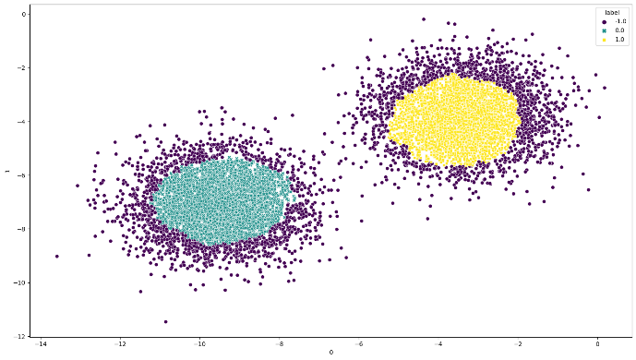 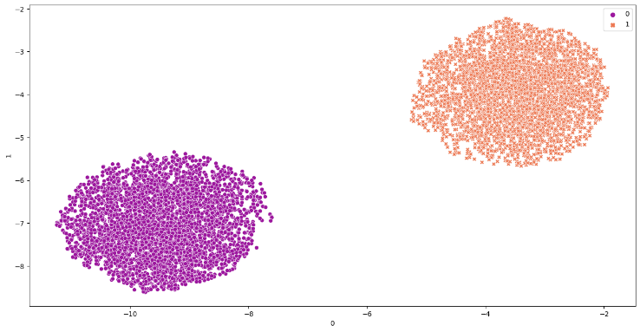

Obtained Outliers Obtained Clusters after removing Outliers

Contamination = 0.025

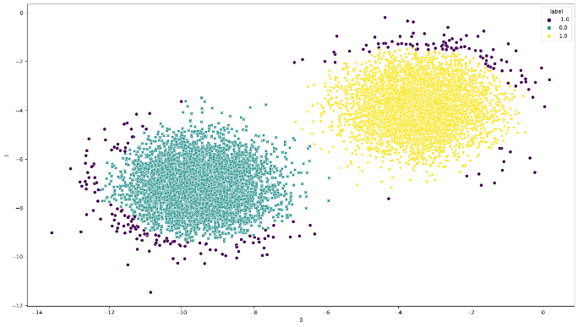 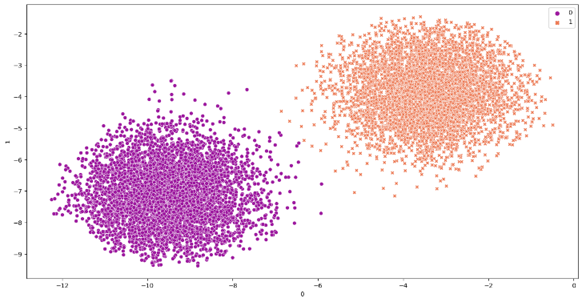

Obtained Outliers Obtained Clusters after removing Outliers

Contamination = 0.05

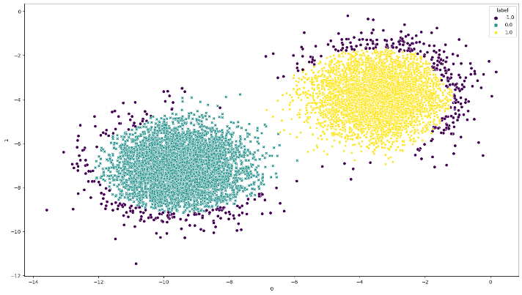 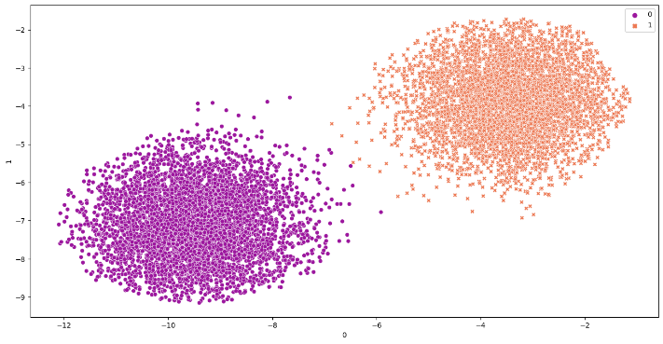

Obtained Outliers Obtained Clusters after removing Outliers

Contamination = 0.1

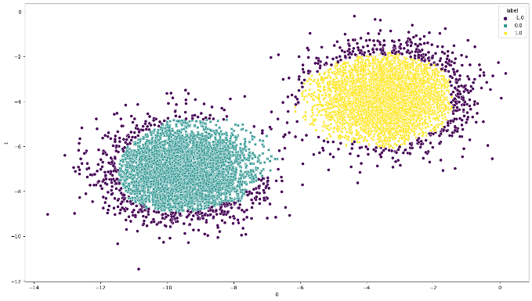 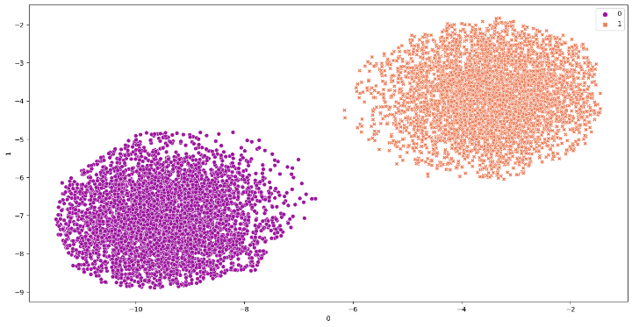

Obtained Outliers Obtained Clusters after removing Outliers

* **Local Outlier Factor**

Contamination = ‘auto’

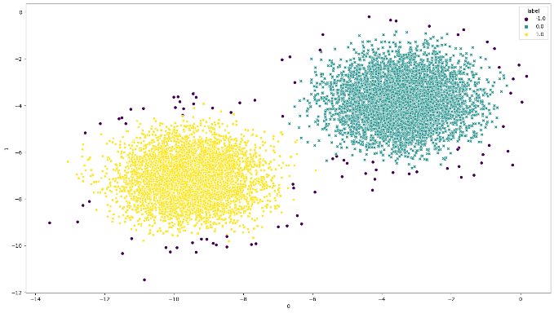 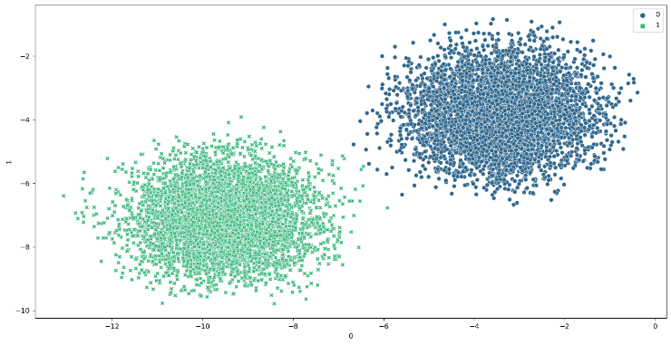

Obtained Outliers Obtained Clusters after removing Outliers

Contamination = 0.025

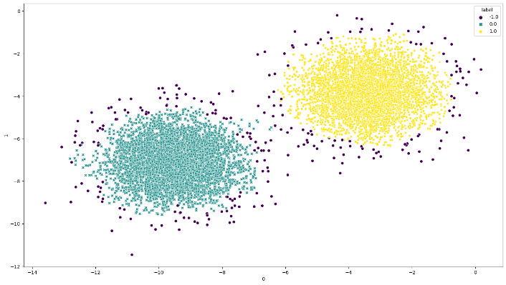 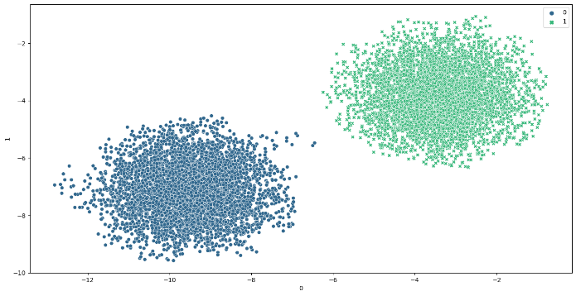

Obtained Outliers Obtained Clusters after removing Outliers

Contamination = 0.05

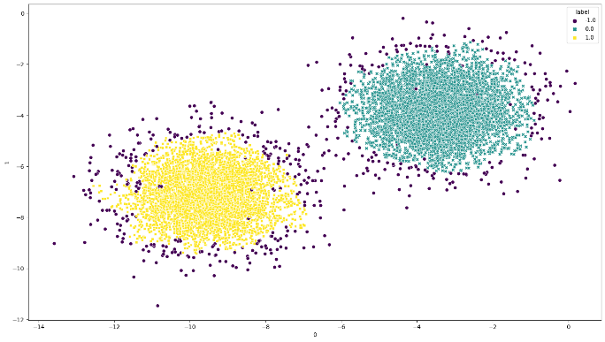 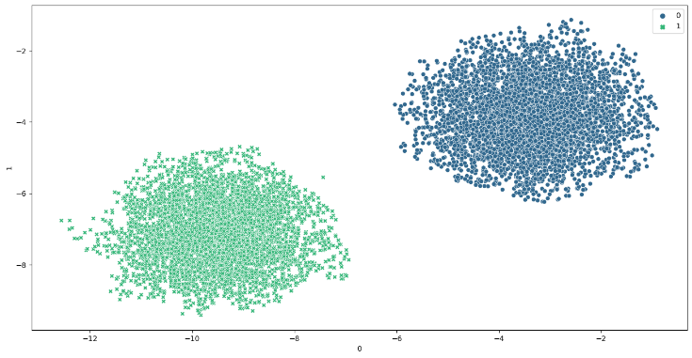

Obtained Outliers Obtained Clusters after removing Outliers

Contamination = 0.1

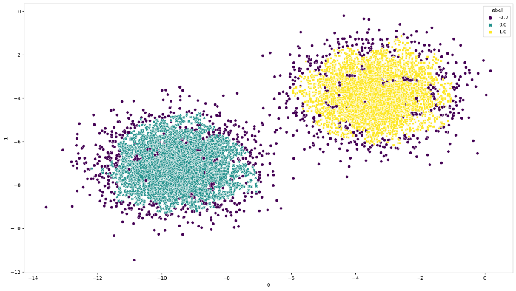 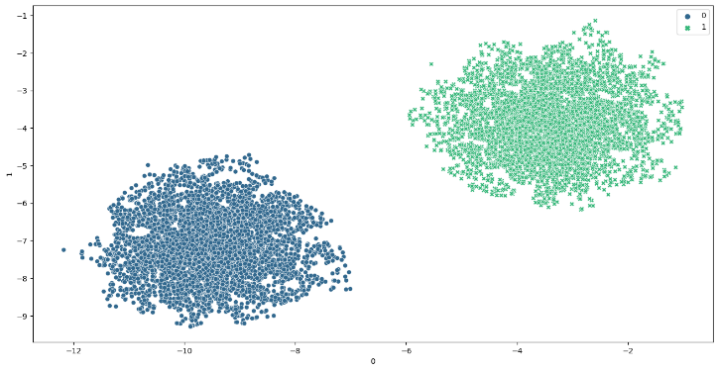

Obtained Outliers Obtained Clusters after removing Outliers

Contamination = 0.05, n_neighbors = 1000

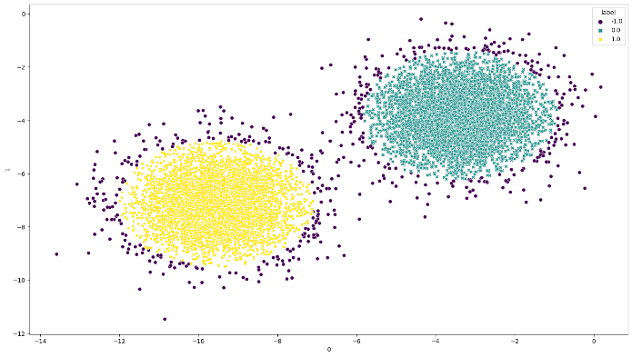 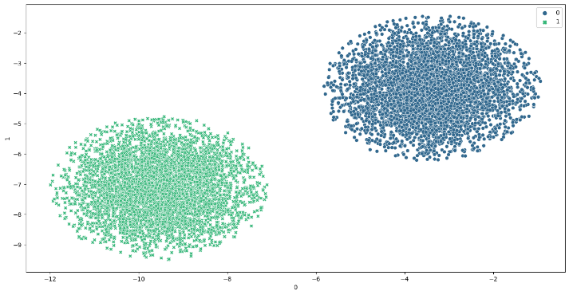

Obtained Outliers Obtained Clusters after removing Outliers

Contamination = 0.1, n_neighbors = 1000

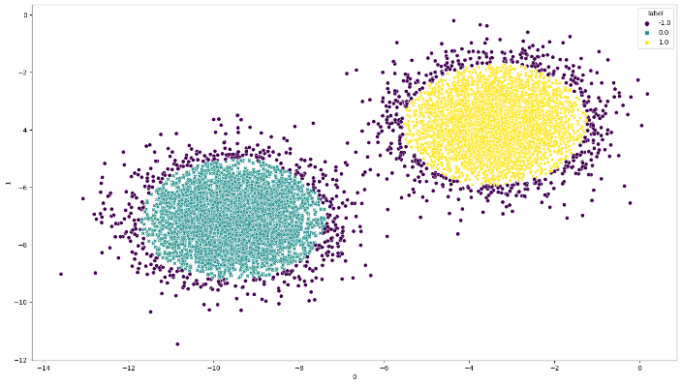 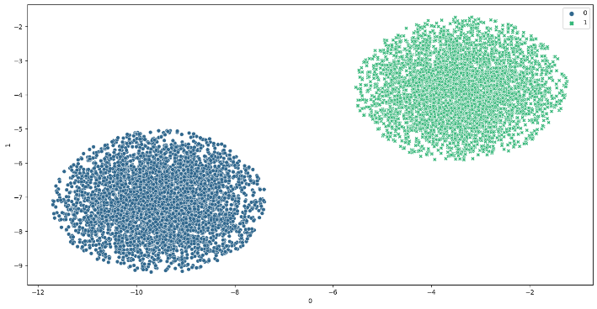

Obtained Outliers Obtained Clusters after removing Outlier

* **One Class SVM**

nu = ‘auto’

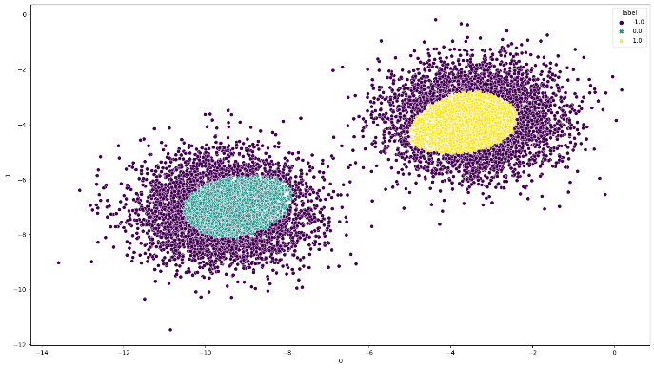 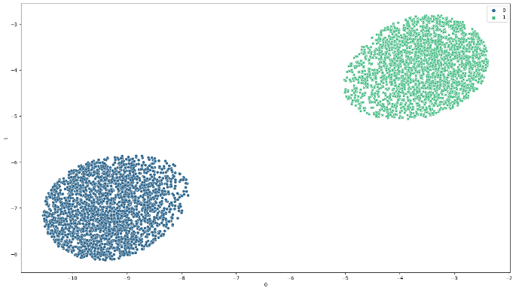

Obtained Outliers Obtained Clusters after removing Outlier

nu = 0.025

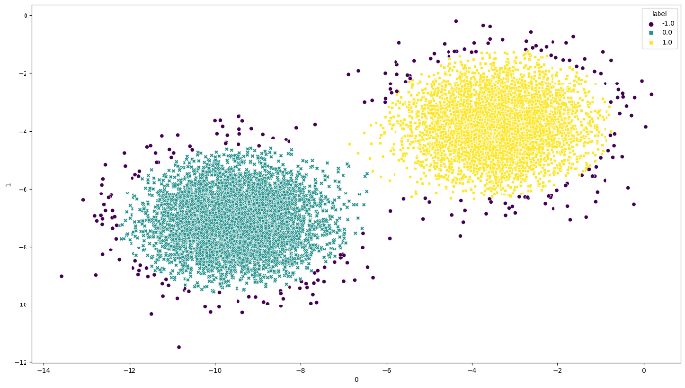 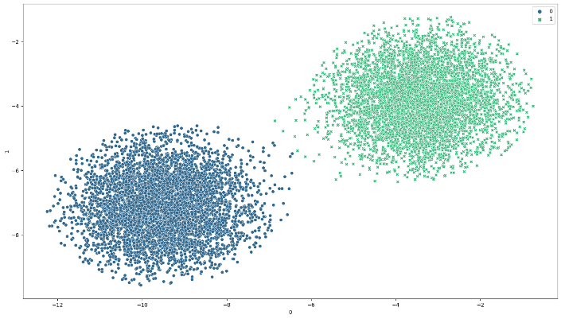

Obtained Outliers Obtained Clusters after removing Outlier

nu = 0.05

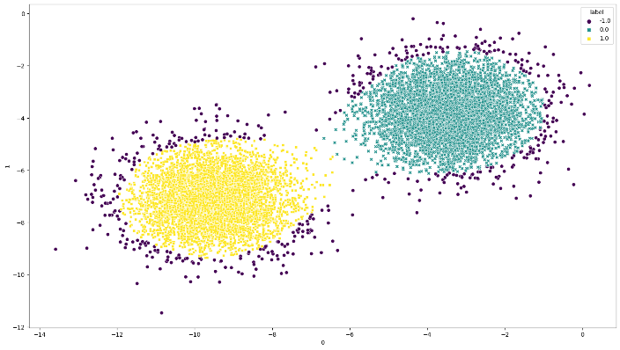 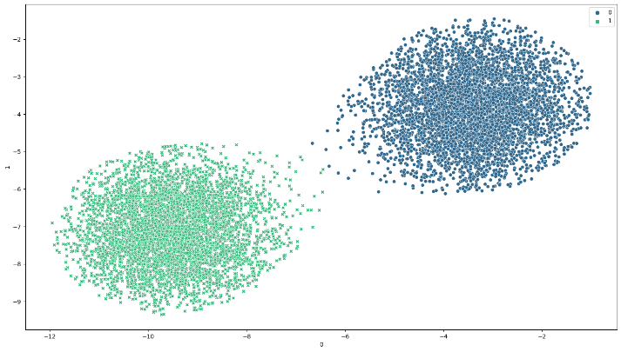

Obtained Outliers Obtained Clusters after removing Outlier

nu = 0.1

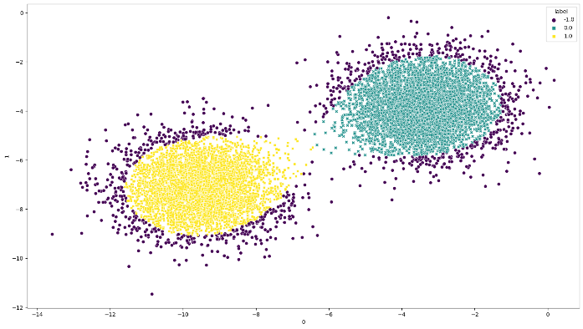 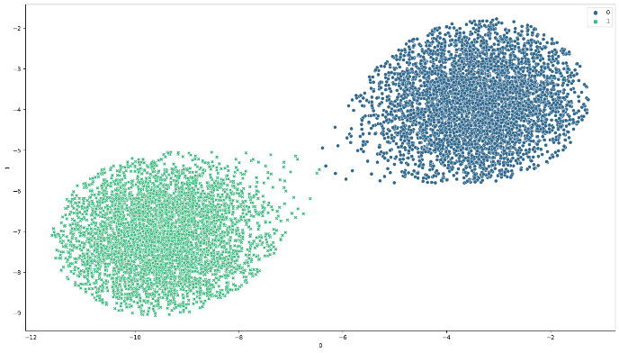

Obtained Outliers Obtained Clusters after removing Outlier

**Outlier Analysis using Scatter Plot for Sparse Cluster**

1. **N : 10000, D : 2, K : 2**

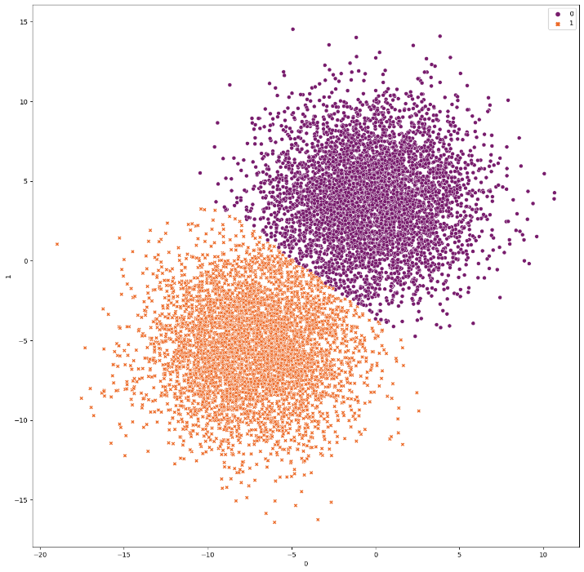

Clusters obtained by KMeans

* **Isolation Forest**

Contamination = ‘auto’

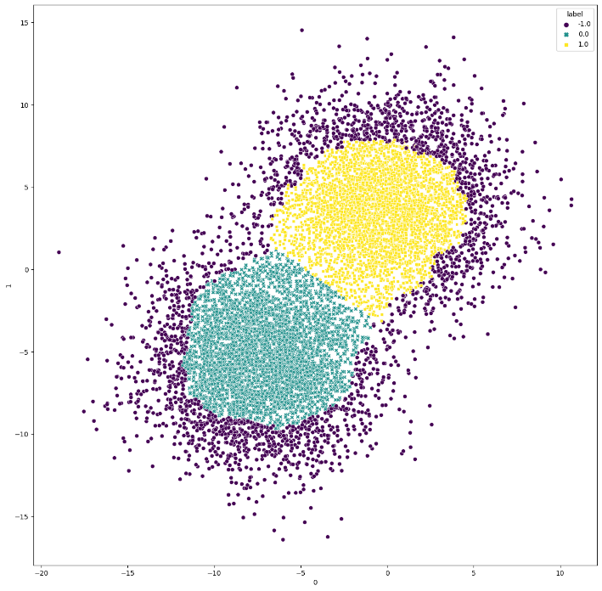 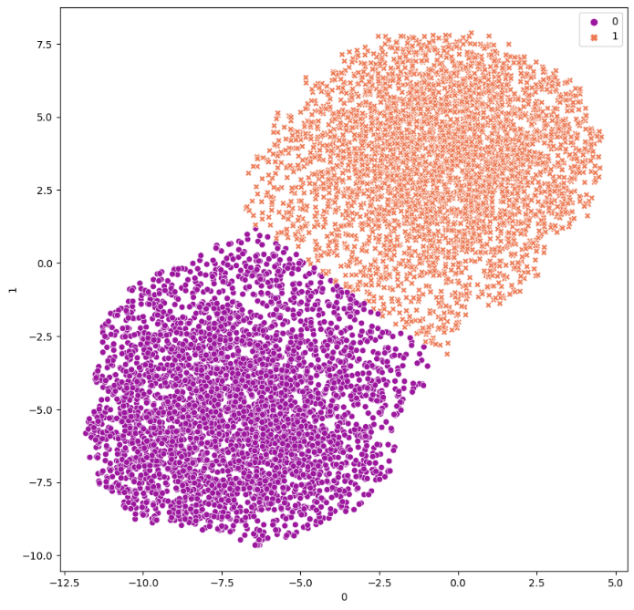

Obtained Outliers Obtained Clusters after removing Outliers

Contamination = 0.05

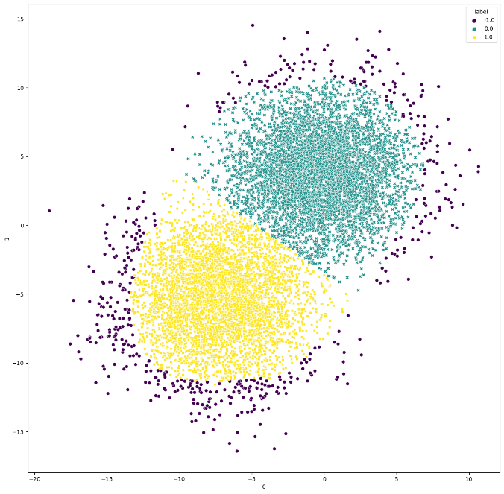 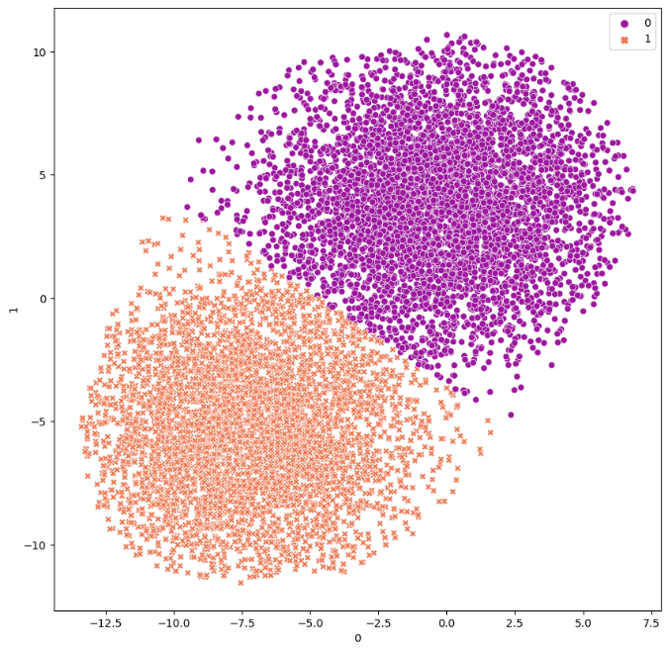

Obtained Outliers Obtained Clusters after removing Outliers

Contamination = 0.1

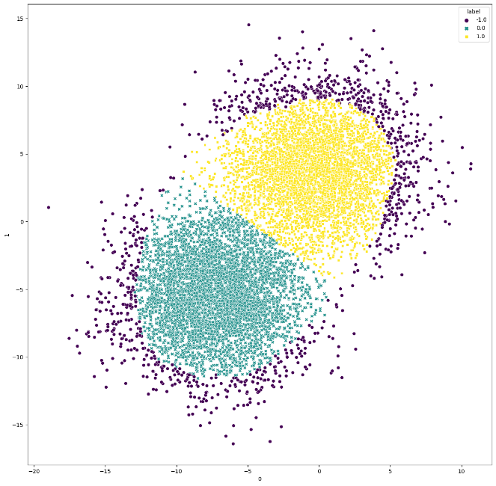 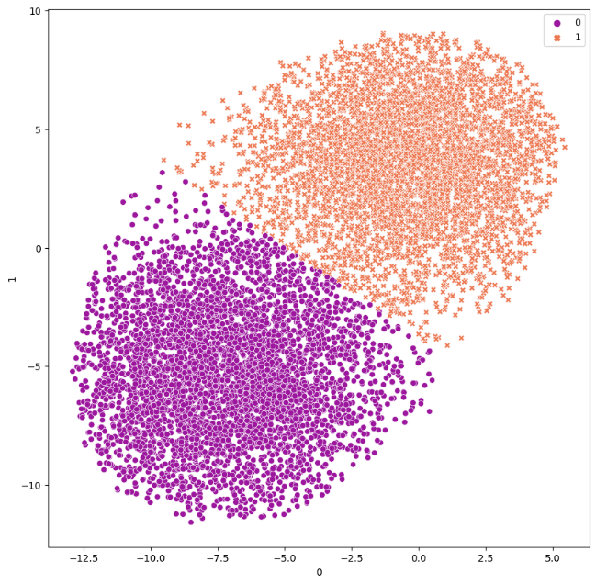

Obtained Outliers Obtained Clusters after removing Outliers

Contamination = 0.15

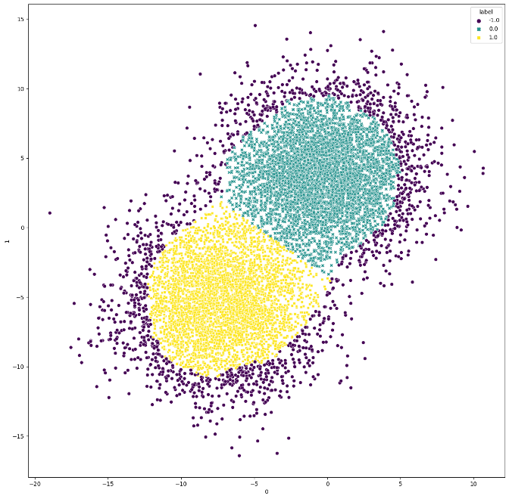 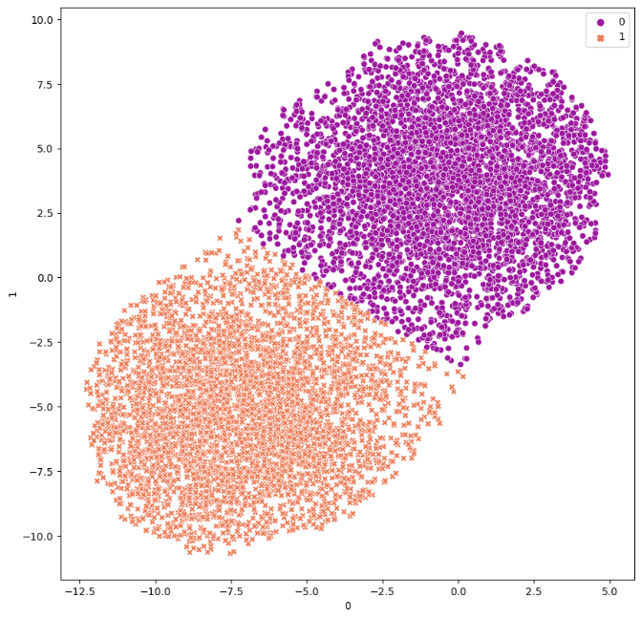

Obtained Outliers Obtained Clusters after removing Outliers

* **Local Outlier Factor**

Contamination = ‘auto’

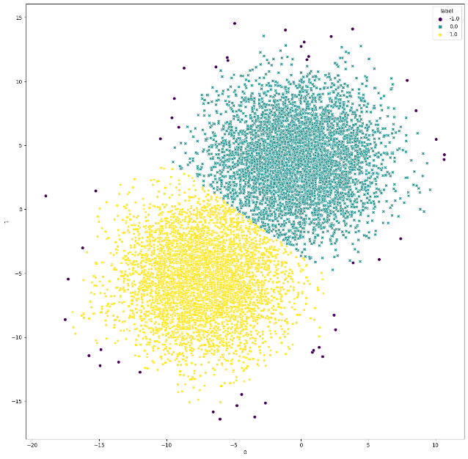 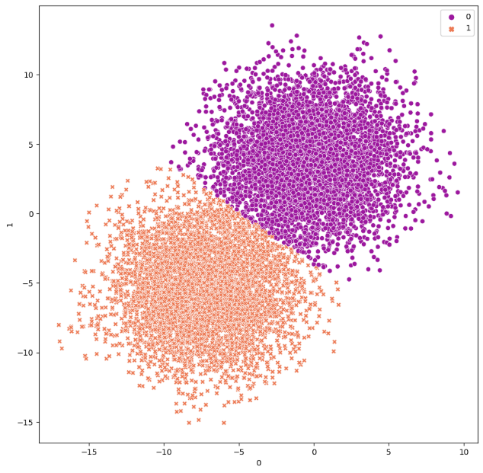

Obtained Outliers Obtained Clusters after removing Outliers

Contamination = 0.05

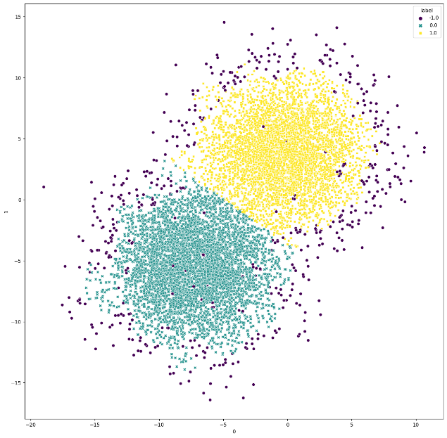 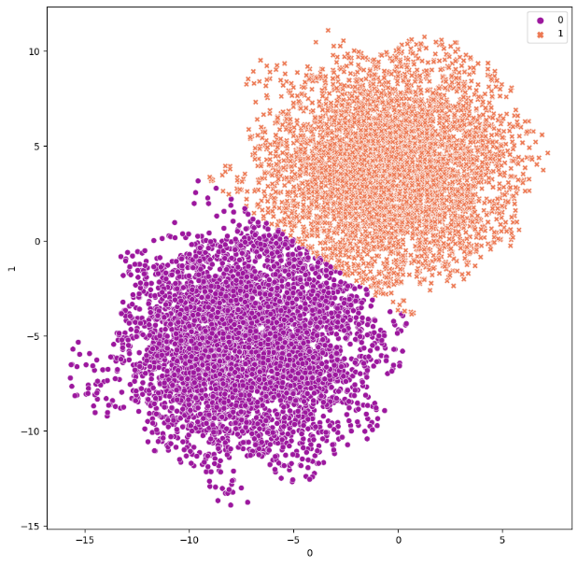

Obtained Outliers Obtained Clusters after removing Outliers

Contamination = 0.1 , n_neighbors = 1000

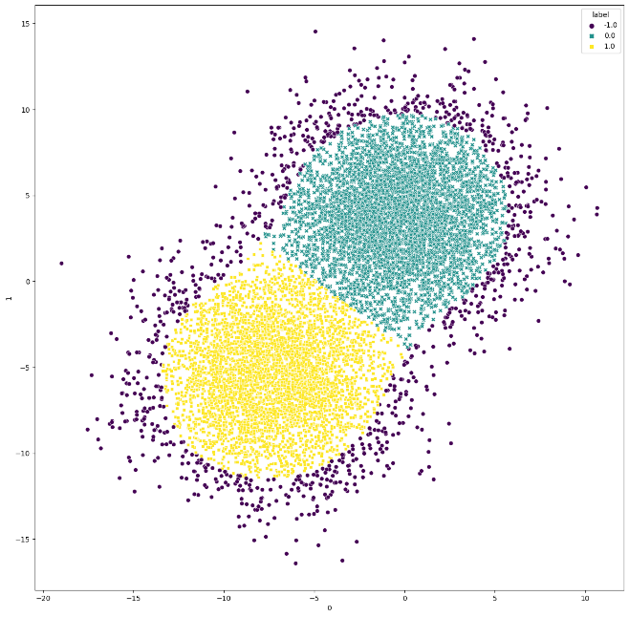 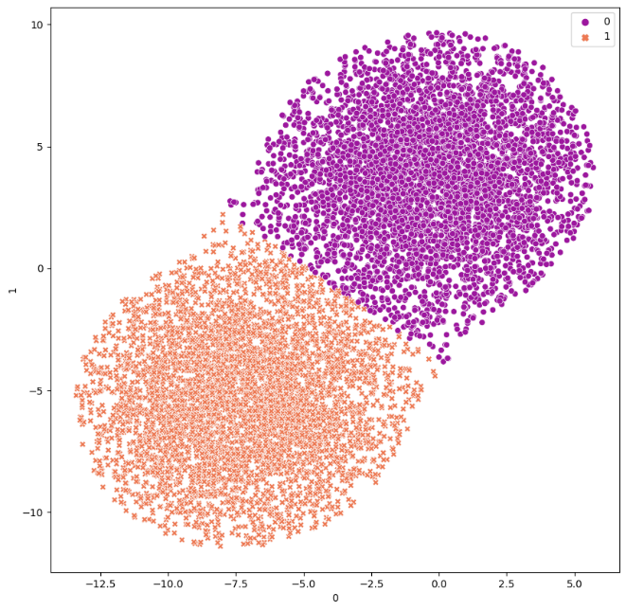

Obtained Outliers Obtained Clusters after removing Outliers

Contamination = 0.15 , n_neighbors = 1000

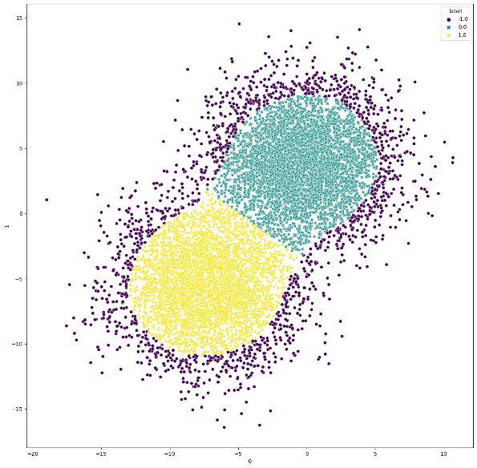 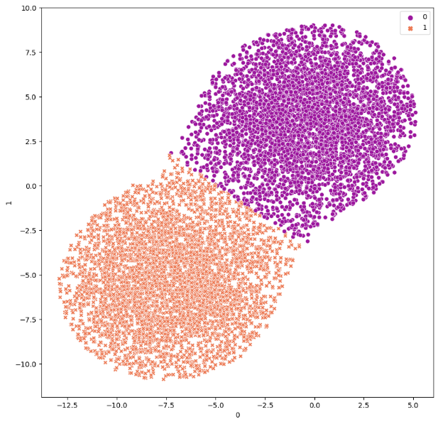

Obtained Outliers Obtained Clusters after removing Outliers

Contamination = ‘auto’, n_neighbors = 1000

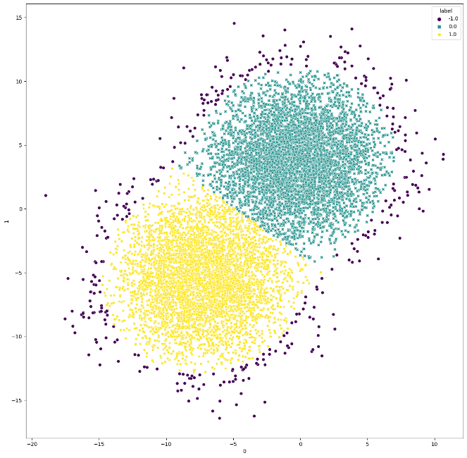 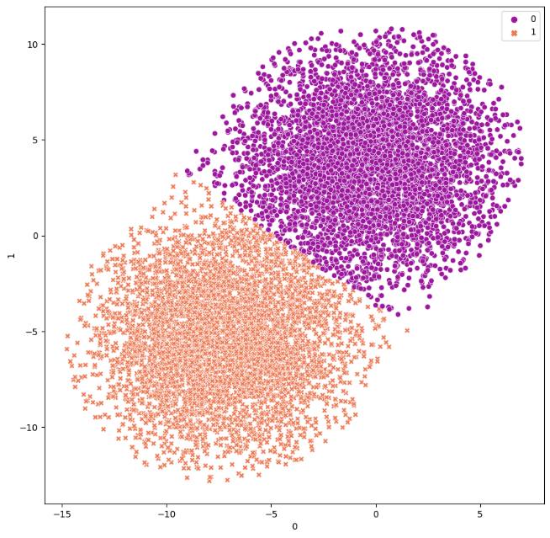

Obtained Outliers Obtained Clusters after removing Outliers